**IOT Based Automated Hydroponic Cultivation System**

Prof.Snehal Laddha,Mitali Waghwani,Esha Choudhari,Ketaki Salway, Manish Rai

Shri Ramdeobaba College of Engineering and Management, Katol Road, Nagpur - 440013

**ABSTRACT**

Hydroponic is a method where the plants are grown in the absence of soil by directly supplying the optimum amount of nutrients that are acquired from the soil in water. Plants grown this manner usually yield more, require less space, and conserve soil and water. Its main aim is to save lots of water, improve the quality of crops avoiding the adverse effects of pesticides and factors affecting quality of soil and save land. The automated hydroponics system based on IOT is developed to facilitate the cultivation and the system can adjust and control important environmental factors that affect plant growth. With the utilization of Internet of things the system is monitored and controlled from anywhere via the web , therefore parameters like pH level,light intensity,electrical conductivity, water level, temperature , and room humidity parameters are often viewed in real time.

Keywords- IOT,Hydroponics,web

# **1. INTRODUCTION**

Hydroponics system is a developing plant system that does not use soil, however makes use of water with Essentials Nutrients to save area planting and not polluted with chemical substances in the soil. Hydroponics has some modern approach and it isn't constrained to plant with water like nutrient film technique, deep flow technique, dynamic root floating technique, etc.

**1.1 Methods of Hydroponics**

1.1.1 Wick system: The simplest technique compared to all the above is wick system, as it does not consume electricity, use pumps or has any moving parts.

1.1.2 Ebb and Flow (flood and drain): This is the most uncommon method, also known as Ebb and Flow technique. The plant roots are not exposed like done in Nutrient Film Technique (NFT)

1.1.3 Nutrient Film Tehnique: A structure similar to PVC pipes is implemented in this technique. A series of plants are grown in line using this form of structure. The nutrient solution is pumped into the pipe like formation and then collected back into the reservoir through the other end, where an outlet is created for the solution to flow out. In other words, recirculation is applied and at the same time, water conservation is proved from this method.

1.1.4 Deep water culture: A reservoir acts as the container to store the nutrient solution. Oxygen, water and nutrient supply is provided by suspending the roots of the crops in this solution.

1.1.5 Drip system: In this system, the nutrient solution is released onto the base of plants and e-nutrient solution is collected and resused.

1.1.6 Aeroponics: This is very similar to Nutrient Film Technique. However, the only difference is that, instead of using a recirculation method, it is replaced by sprinklers. These sprinklers do the task of misting the root zone with nutrient solution(Pawar et al., 2019)

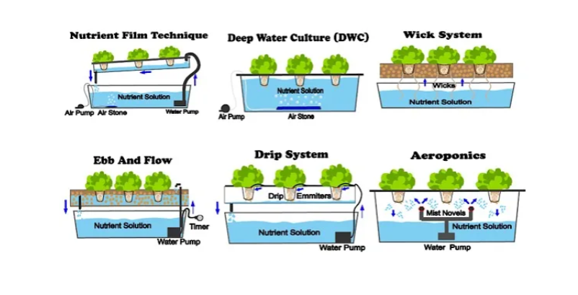Figure 1: Methods of Hydroponics

**1.2 Why Hydroponics?**

Soil is typically the foremost available growing medium for plants. It provides anchorage, nutrients, air, water, etc. for successful plant growth. However, soils do pose serious limitations for plant growth too, at times. Presence of disease causing organisms and nematodes, unsuitable soil reaction, unfavorable soil compaction, poor drainage, degradation because of erosion etc. are a number of them. additionally , conventional crop growing in soil (Open Field Agriculture) is somewhat difficult because it involves large space, lot of labour and huge volume of water. Moreover, some places like metropolitan areas, soil isn't available for crop growing in the least , or in some areas, we discover scarcity of fertile cultivable arable lands because of their unfavorable geographical or topographical conditions . Of late, another significant issue experienced since is that the difficulty to rent labour for conventional open field agriculture . Under such circumstances, soil-less culture are often introduced successfully.It is a method of growing plants using mineral nutrient solutions, without soil.(Sardare, 2013a)

# **2. LITERATURE SURVEY**

In 2020,(Lakshmanan et al., 2020) proposed a design and implementation of an automated smart hydroponics system using the internet of things. The challenges to be solved with this system are the increasing food demand in the world, the need for a market for new sustainable methods of farming using the Internet of Things. The design was implemented using NodeMcu, Node Red, MQTT and sensors that were chosen during component selection based on required parameters and sending it to the cloud to monitor and be processed. Investigation on previous works done and a review of Internet of Things and Hydroponic systems were done. First the prototype was constructed, programmed and tested, as well as sensor data between two different environments were taken and monitored on a cloud-based web page with mobile application. Moreover, a bot has been introduced to control the supply chain and for notification purposes. The system improved its performance and allowed it to successfully achieve the aim of the entire system implemented. There are some limitations which can be improved as future work such as including data science with the usage of the artificial intelligence to further improve the crops and get better outcome. Lastly to design end user platform to ease user interaction by using attractive design with no technical configuration involved.

(Sihombing et al., 2018) aims to develop a tool using Arduino uno microcontroller and a loyal smart phone. The developed tool uses a technology to continuously watch the rush of nutrients to the shop, device can also shoot data of temperature and fluid reach around the shop to the doper. Doper can view these data using smartphone. Nutritional water rush system by exploiting detector distance has been successfully done.

(Satoh, 2018) developed a compact hydroponic agriculturist and are conducting accomplishment essays to realize an farming service diligence that uses vacant spaces in metro areas. In order to deliver a full-fledged accomplishment approach for fruit and vegetables to freshmen in farming, a low- cost detector module and a agriculturist with an integrated remote- control system have been developed. MQTT, a less weighted protocol for IoT is used to cover detector data and to control a pump. Data is securely encoded using TLS/ SSL. In addition to covering detector data, a USB- connected camera- grounded still- image photography function with move discovery is included.

(Sisyanto et al., 2017) came up with new idea, hydroponic smart farming system that may be monitored on-line via message courier is developed. The planning that's created will monitor necessary parameters within the farming system, like intensity level, temperature, humidity, pH, nutrient temperature, and Electrical conduction (EC). The prototype is intended using Raspberry Pi 3 that connects directly with sensors like DHT11 module, LDR, pH device module, and Electrical conductivity device. message bot that enables to watch sensors on-line via message is additionally created. With the mixing of the Physical System (Raspberry Pi, sensor) and social system (Telegram Messenger) connected on-line via net or cyber, the hydroponic system watching becomes a lot of versatile.

(Hariono et al., 2021) aims to conduct data acquisition on an IOT-based hydroponic plant automation system using ESP8266. Data acquisition is used to monitor temperature data from the DS18B20 sensor, PPM levels from the TDS Meter v1.0 sensor, Ph levels from the Ph Meter v1.1 sensor, water level from TIP 42C, periodic plant growth monitoring based on an image from ESP32 Cam, and as an alternative energy backup using sonar panels on hydroponic plants. Acquired data from each sensor is sent to the Firebase real-time database, every data change is saved to the MySQL server database. The system development method uses the waterfall which includes requirements analysis, system design, implementation, and testing. The results of data acquisition are displayed on the dashboard page in realtime so that they can be easily read by the user. The results of functional and effectiveness testing went well. Monitoring and controlling are done through the website.

# **3. EQUIPMENTS**

3.1 Esp 8266 Node MCU :

Node MCU is an Arduino board built in Wi-Fi module and it is used to work with all sensors of the system and to send information that the sensor received into the database via Wi-Fi. MCU is the heart of IoT systems to process data and run software stacks interfaced to a wireless device for connectivity.(Kularbphettong et al., 2019)

3.2 DHT 11:

Temperature and Humidity sensor: DHT11 performs this task. For temperatures up to 80 degree Celsius, they provide an accuracy of ±0.1% and a fair response speed of 2 seconds. Their humidity measuring range is 0 to 100%, which is sufficient for this system. The plants are very sensitive to fluctuating temperature and humidity, if both of these parameters are high.; plants lack their ability to transpire. Thus, it has an adverse effect on their growth. However, they adapt to a higher humidity range once their roots have matured. An RTC (Timer circuit) can be implemented in order to keep track of the time, such that the system will detect whether it is day or night.(Pawar et al., 2019)

3.3 PH sensor:

The pH sensor is an electronically chemical fission device to measure the pH of the water by using acid-based measurement and the suitable pH level is between 5.5 and 7.(Kularbphettong et al., 2019)

3.4 TDS Meter:

TDS sensor kit is compatible with Arduino controllers, plug and play, easy to use.

It can be applied to measure TDS value of the water, to reflect the cleanliness of the water.

TDS (Total Dissolved Solids) indicates that how many milligrams of soluble solids dissolved in one liter of water.Input Voltage of DC 3.3 ~ 5.5V and Output Voltage of 0 ~ 2.3V it has Working Current of 3 ~ 6mA And Range Varies from Range: 0 ~ 1000ppm.

# **4. METHODOLOGY**

Initially, the seeds are grown in cocopeat as shown in figure 1. to develop small saplings which are then transferred into net pots where their roots are supported with inert media and exposed to the nutrient-rich oxygenated water solution.

The plants cultivated in the container required parameters in ranges as follows:

• For the surrounding ambient temperature, the plants require 15°C to 21°C. Similarly,

• Humidity: 10% - 50%

• White Light of 300 - 800 lumens

• pH: 5.5 - 6.5 (Nutrient solution)

• ppm: 800 ppm-1500ppm (Nutrient solution)

As we can see in the block diagram ,there are sensors like Ph sensor to measure the PH of solution, TDS meter is used to indicate the Total Dissolved Solids in a solution, usually water by measurements its conductivity by the dissolved salts and minerals and then DHT 11 to measure the Temperature and Humidity of the surroundings.

For single bus data format, synchronisation between DHT11 and NODE MCU sensor is used. One communication process takes 4 milliseconds. All the sensors are connected to Our microcontroller Node MCU.As the supply starts the Node Mcu starts obtaining values from the sensors through wifi module. After collecting the data from sensors It then sends it to the Application through wifi module.And the Values of Ph,temperature ,Humidity and total dissolves solids can be seen on the application .

On the other hand here Grow lights has been used so the plants will get ample of the light to Grow efficiently .Realy and Water Pump is used to supply Nutrient solution to the the Structure.

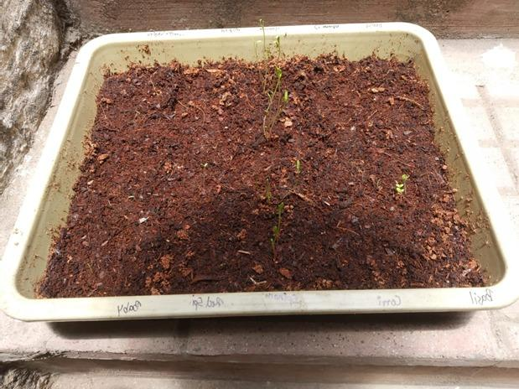 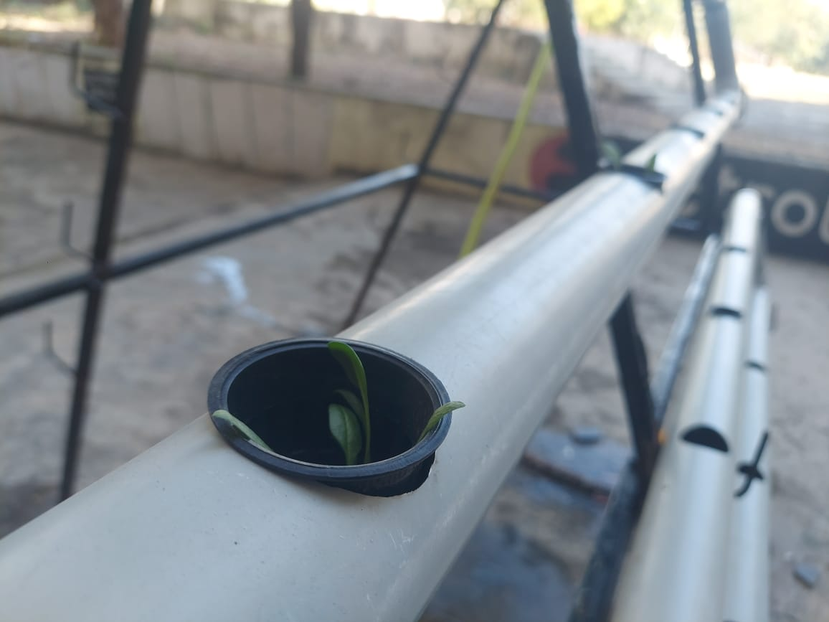

Figure 2: Germination of spinach seed Figure 3: Transplanting of plants into net pot

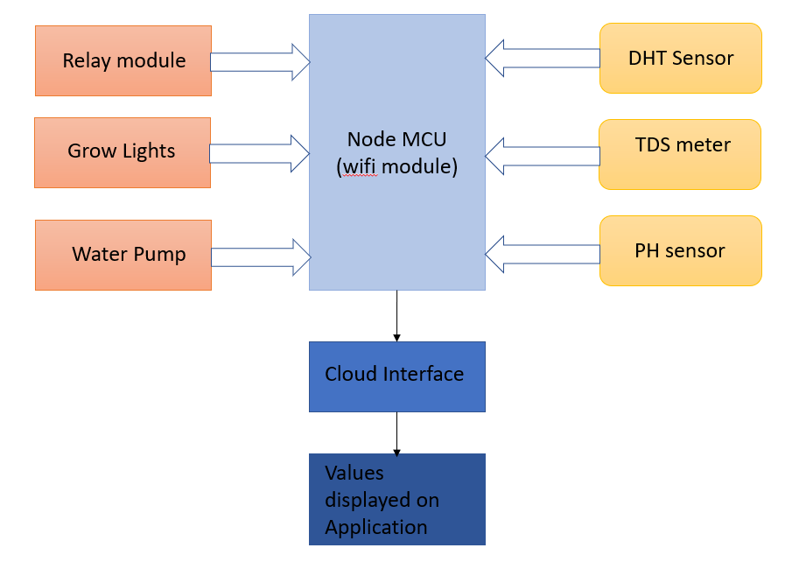

Figure 4: Block Diagram of automated hydroponics system

# 

# **5. RESULT:**

This project is IoT based as it includes connecting the hardware to an

existing WiFi network and communicating with a cloud

based realtime database to monitor after the Physical setup ,

we interfaced the various sensor with NodeMCU(ESP8266) as shown in figure.5 below.

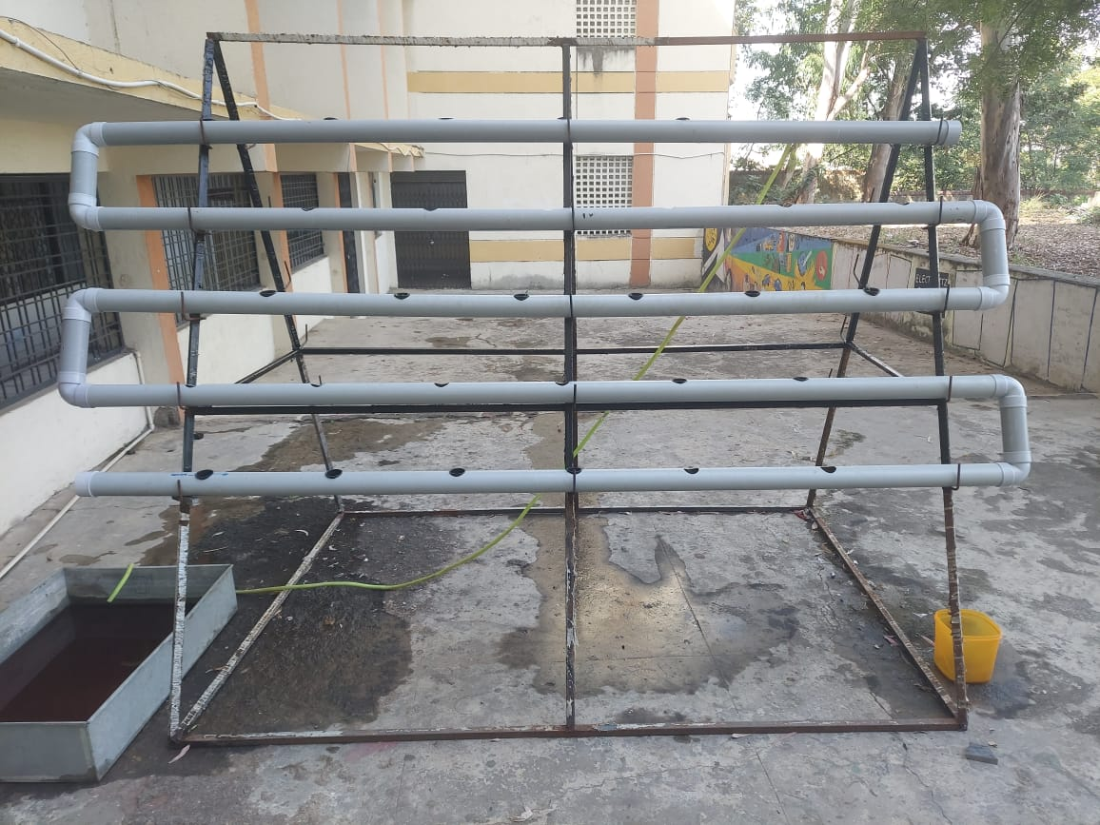 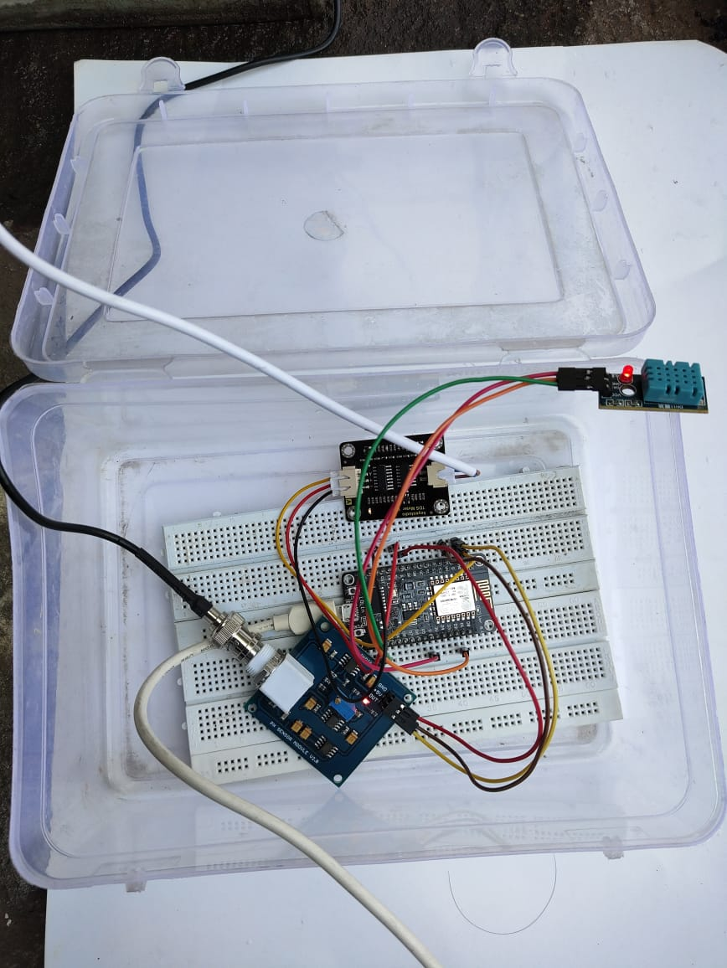

Figure 5: Hardware setup

The data collected from various sensors was sent to ThingSpeak Cloud.

As shown in figure.6, We can see that the various parameter such as

humidity,Temperature,ph value and tds value is displayed.

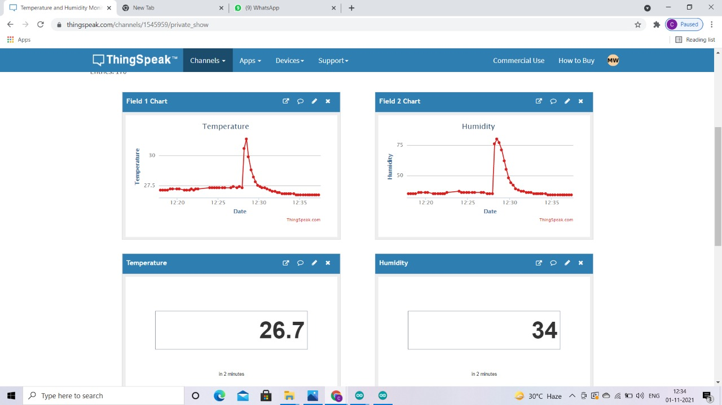

Figure 6: (Thingspeak)

We have accessed the data through ThingSpeak Cloud and it was monitored and displayed through the mobile application i.e MIT A2 companion as shown in figure.7

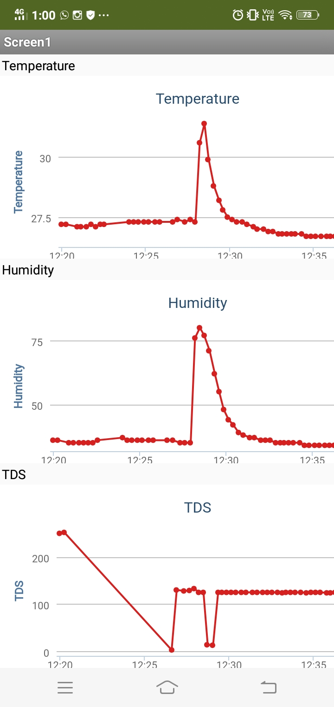

Figure 7: Results displayed on Mobile Application (MIT A2 Companion)

After the germination of seeds we transferred the saplings into the physical structure and started the flow of nutrient solution. After 3 weeks we observed that the saplings have grown as shown in the figure 8

So we have used spinach in our project and the time needed for a spinach plant to grow fully is 5-6 weeks under the required climatic conditions.

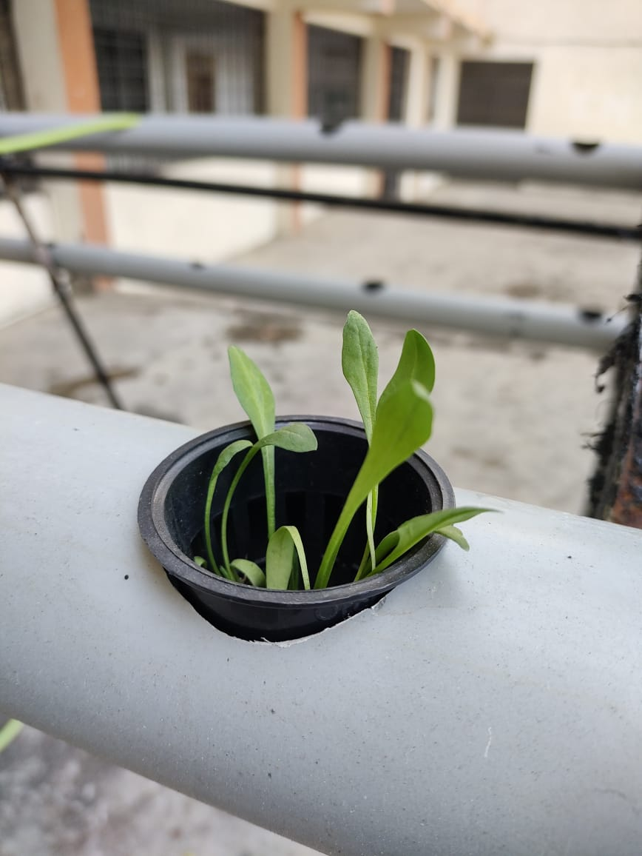

Figure 8: Plant grown in hydroponics system

# **6. CONCLUSION:**

Hydroponic systems are highly effective techniques utilized in several agricultural domains and also against natural calamities. However this technique requires less number of workers, but still it's expensive and sophisticated but the productivity is high. This idea is often switched to more economical method or development of some equipment can be done by the farmer or concerned person All the hydroponics system requires the PH and nutrient levels to be checked, so knowledge of these are a must. Any nation can increase their food productivity by that specialize in such system, either set up urban farms or food parks under government supervision or either in villages. This system if utilized in a wise manner, can lead to the self sustainability.

# 

# **7. FUTURE SCOPE**

Hydroponics with IoT gives better results not only when the nutrient solution monitoring is done but also its management has to be implemented.The water base system can be completely automated so the farmers need not be present every time to ensure the high-quality crop. and notifying the user to take action whenever needed. So, in future, hydroponics system there is an enormous increase in urban areas and even when it is combined with Internet of Things. By using hydroponic technique space problem in India will be solved in future.

# **REFERENCES**

[1] Kularbphettong, K., Ampant, U., & Kongrodj, N. (2019). An Automated Hydroponics System Based on Mobile Application. *International Journal of Information and Education Technology*, *9*, 548–552. https://doi.org/10.18178/ijiet.2019.9.8.1264

[2] Lakshmanan, R., Guedi, M., Perumal, S., & Abdulla, R. (2020). Automated smart hydroponics system using internet of things. *International Journal of Electrical and Computer Engineering (IJECE)*, *10*, 6389.

[3] Pawar, S., Tembe, S., Acharekar, R., Khan, S., & Yadav, S. (2019). Design of an IoT enabled Automated Hydroponics system using NodeMCU and Blynk. *2019 IEEE 5th International Conference for Convergence in Technology (I2CT)*, 1–6. https://doi.org/10.1109/I2CT45611.2019.9033544

[4] Sardare, M. (2013). A REVIEW ON PLANT WITHOUT SOIL - HYDROPONICS. *International Journal of Research in Engineering and Technology*, *02*, 299–304. https://doi.org/10.15623/ijret.2013.0203013

[5] Satoh, A. (2018). A Hydroponic Planter System to enable an Urban Agriculture Service Industry. *2018 IEEE 7th Global Conference on Consumer Electronics (GCCE)*, 281–284. https://doi.org/10.1109/GCCE.2018.8574661

[6] Sihombing, P., Karina, N. A., Tarigan, J. T., & Syarif, M. I. (2018). Automated hydroponics nutrition plants systems using arduino uno microcontroller based on android. *Journal of Physics: Conference Series*, *978*, 012014. https://doi.org/10.1088/1742-6596/978/1/012014

[7] Sisyanto, R. E. N., Suhardi, & Kurniawan, N. B. (2017). Hydroponic smart farming using cyber physical social system with telegram messenger. *2017 International Conference on Information Technology Systems and Innovation (ICITSI)*, 239–245. <https://doi.org/10.1109/ICITSI.2017.8267950>

[8] Hariono, T., Putra, C., & Hasbullah, K. A. W. (2021). Data Acquisition for Monitoring IoT-Based Hydroponic Automation System Using ESP8266. 1(1), 1–7.

[9] Griffiths, M. D. (2014). *The Design and Implementation of a Hydroponics Control System*.

[10] Types of hydroponics- https://hydrobuilder.com/learn/types-of-hydroponics-systems.